Image Processing

MATLAB

LAB Assignment

Fourier Transform

Submitted by:

Akanksha Bansal

071213

**Important functions used**

Abs Absolute value and complex magnitude

angle Phase angle

cplxpair Sort complex numbers into complex conjugate pairs

fft Discrete Fourier transform

fft2 2-D discrete Fourier transform

fftn N-D discrete Fourier transform

fftshift Shift zero-frequency component to center of spectrum

fftw Interface to FFTW library run-time algorithm tuning control

ifft Inverse discrete Fourier transform

ifft2 2-D inverse discrete Fourier transform

ifftn N-D inverse discrete Fourier transform

ifftshift Inverse FFT shiftnext

pow2 Next higher power of 2

unwrap Correct phase angles to produce smoother phase plots

**What is more important Magnitude or phase?**

I believe that both play an equal role while determining the image. Phase helps in determining the features of the image while magnitude associates an intensity value with that phase value. But without phase the cannot be reconstructed even when we can construct a image without magnitude.

**Fourier Transform and image reconstruction using phase or magnitude only**

a=imread('im11.jpg');

b=im2double(a);

f=fft(a);%Fourier Transform 1 D

fshift=fftshift(f); %Fourier Transform 1 D with shift

mag=abs(f);

i=ifft(f);

f2=fft(b);

mag2=abs(f2);

i2=ifft(mag2);

subplot(2,3,1); imshow(a); title('Image');

subplot(2,3,2); imshow(f); title('Fourier Spectrum ');

subplot(2,3,3); imshow(i); title('image from phase');

subplot(2,3,4); imshow(mag2); title('Magnitude of Fourier Spectrum');

subplot(2,3,5); imshow(i2); title('Image from Magnitude');

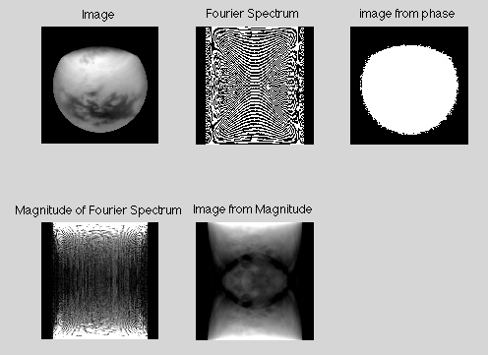

**Fourier Spectrum with shift and Inverse Fourier Transform**

a=im2double(imread('im11.jpg'));

f=fft(a);%Fourier Transform 1 D

fshift=fftshift(f);

mag=abs(f);

i=ifft(f);

f2=fft2(a);

mag2=abs(f2);

i2=ifft2(f2);

subplot(3,3,1); imshow(a); title('Image');

subplot(3,3,2); imshow(f); title('Fourier Spectrum');

subplot(3,3,3); imshow(fshift); title('Fourier Spectrum with shift');

subplot(3,3,4); imshow(mag); title('magnitude of Fourier Spectrum');

subplot(3,3,5); imshow(i); title('Inverse Fourier Spectrum');

subplot(3,3,6); imshow(f2); title('Fourier Spectrum 2');

subplot(3,3,7); imshow(mag2); title('magnitude of Fourier Spectrum 2');

subplot(3,3,8); imshow(i2); title('Inverse Fourier Spectrum 2');

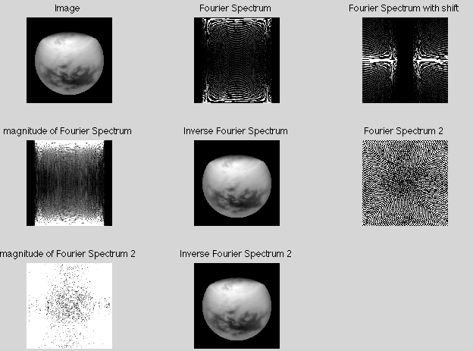

**Low pass filters**

f=im2double(rgb2gray(imread('im_0.jpg')));

PQ=size(f);

[U, V]=dftuv(PQ(1),PQ(2));

D0=0.05*PQ(2);

F=fft2(f,PQ(1),PQ(2));

Gau=exp(-(U.^2+V.^2)/(2*(D0^2)));

g=dftfilt(f,Gau);

D=sqrt(U.^2+V.^2);

id=double(D<=D0);

Idim=dftfilt(f,id);

btw=1./(1+(D./D0).^(2*2));

btwim=dftfilt(f,btw);

subplot(3,3,1); imshow(f); title('Image');

subplot(3,3,2); imshow(fftshift(Gau)); title('Fourier Spectrum Gaussian');

subplot(3,3,3); imshow(g); title('Gaussian');

subplot(3,3,5); imshow(fftshift(id)); title('Ideal');

subplot(3,3,6); imshow(Idim); title('Ideal image');

subplot(3,3,8); imshow(fftshift(btw)); title('Butter worth');

subplot(3,3,9); imshow(btwim); title('butter worth image');

function [U, V]=dftuv(M,N)

u=0:(M-1);

v=0:(N-1);

idx=find(u>M/2);

u(idx)=u(idx)-M;

idy=find(v>N/2);

v(idy)=v(idy)-N;

[V,U]=meshgrid(v,u);

end

function [ g ] = dftfilt( f,H )

F=fft2(f,size(H,1),size(H,2));

g=real(ifft2(H.*F));

g=g(1:size(f,1),1:size(f,2));

end

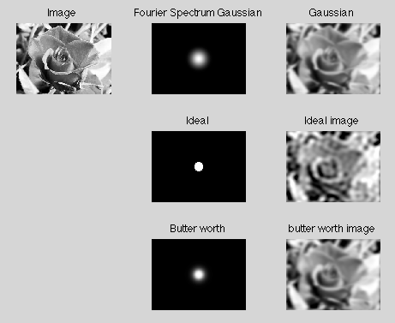

**High pass filtering**

f=im2double(imread('2.jpg'));

PQ=size(f);

[U, V]=dftuv(PQ(1),PQ(2));

D0=0.05*PQ(2);

F=fft2(f,PQ(1),PQ(2));

Gau=exp(-(U.^2+V.^2)/(2*(D0^2)));

HGau=1-Gau;

g=dftfilt(f,HGau);

D=sqrt(U.^2+V.^2);

id=double(D<=D0);

Hid=1-id;

Idim=dftfilt(f,Hid);

btw=1./(1+(D./D0).^(2*2)); % n=1

Hbtw=1-btw;

btwim=dftfilt(f,Hbtw);% change to image

subplot(3,3,1); imshow(f); title('Image');

subplot(3,3,2); imshow(fftshift(HGau)); title('Fourier Spectrum Gaussian');

subplot(3,3,3); imshow(g); title('High pass Gaussian');

subplot(3,3,5); imshow(fftshift(Hid)); title('high pass Ideal');

subplot(3,3,6); imshow(Idim); title('Ideal image');

subplot(3,3,8); imshow(fftshift(Hbtw)); title('Butter worth');

subplot(3,3,9); imshow(btwim); title('butter worth image');

